
Selection 5: #Adhesive Labels #Hang Tags #Ribbon Tapes #Film Rolls v2024.9.2
Target Users: Adhesive Manufacturers, Printing Plants, Card Manufacturers, Garment Factories
Destruction Media: 3M Tesa Avery Labels, Fabric Tags, Stickers, X-ray Films, Mobile Screens, and Screen Protectors
 | Plan1: YD-3120C | Plan2: YD-310CC | Plan3: YD-PSJ300ES | Plan4: YD-PSJ300-2P-1.5KW | Plan5: YD-330CC | Plan6: YD-338CC26 | Plan7: YD-PSJ350
Pricing USD | $1406 | $2653 | $2816 | $5600 | $5495 | $5642 | $14102
Labels Entry Image | 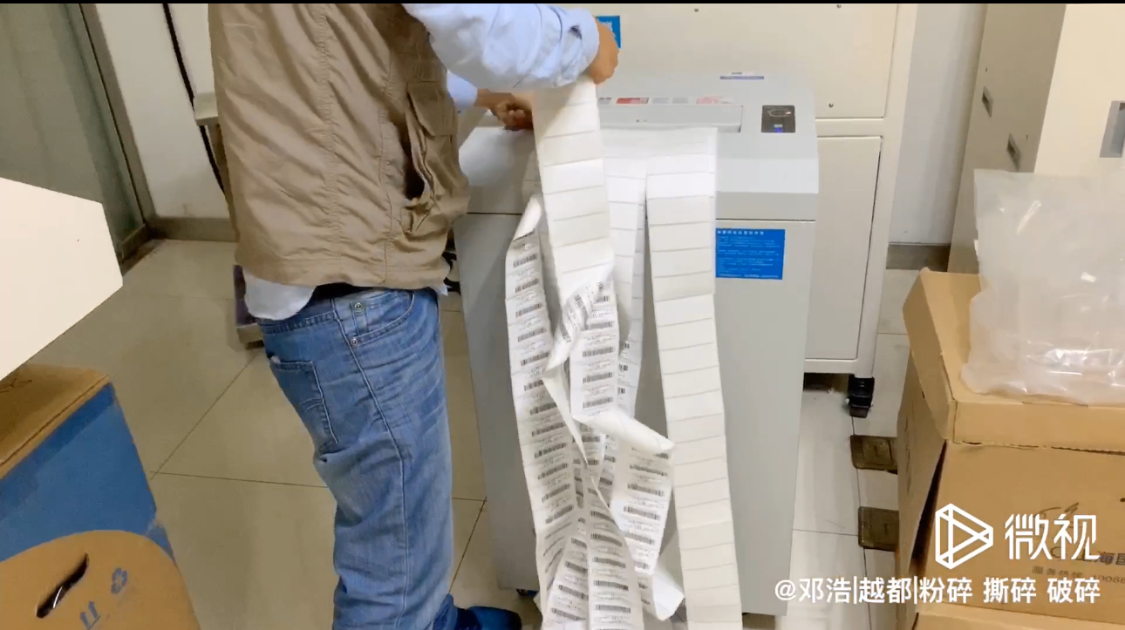 | 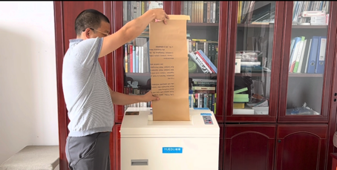 | 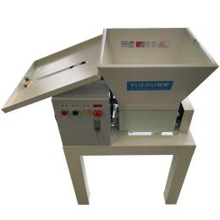 | 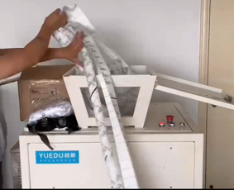 | 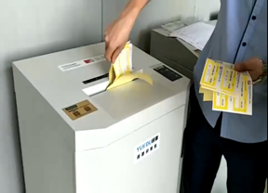 | 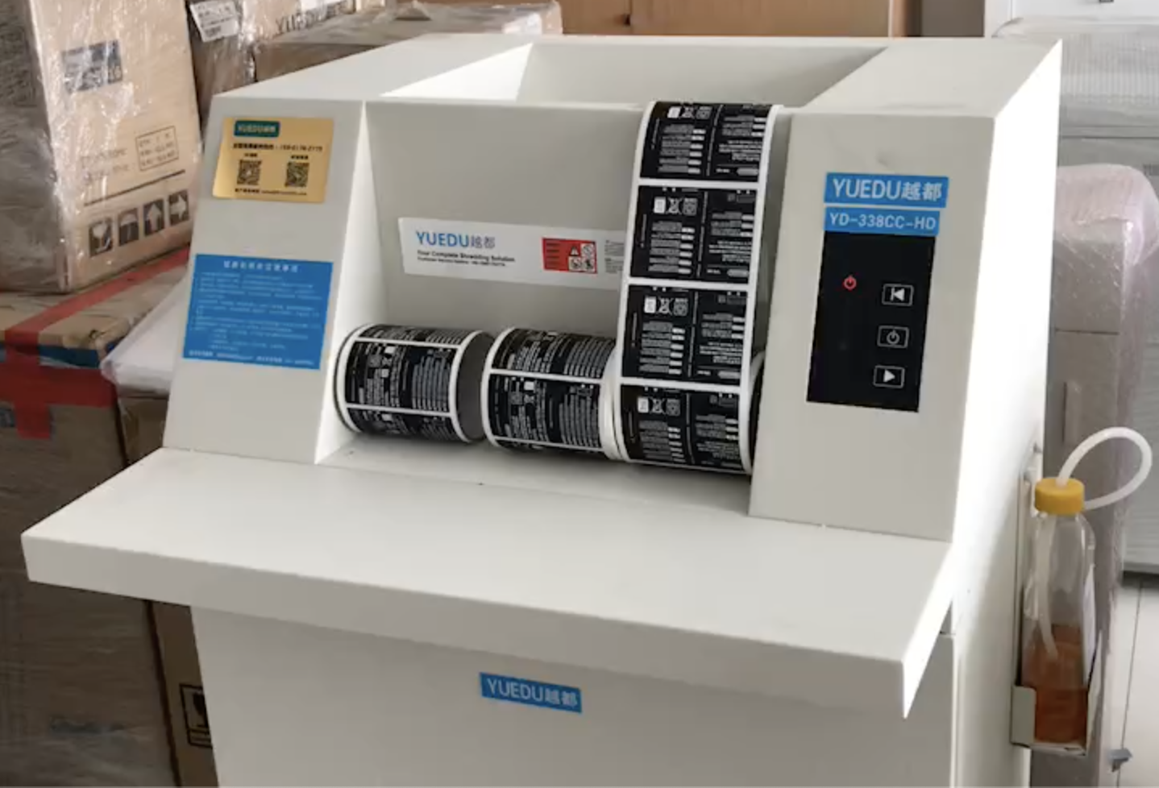 | 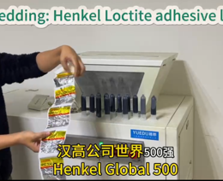
Full Image | 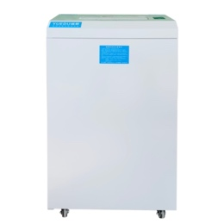 | 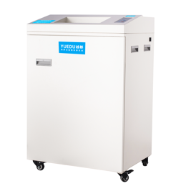 | 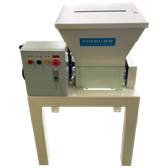 | 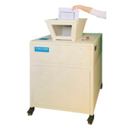 | 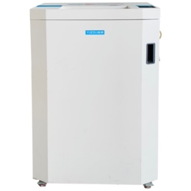 | 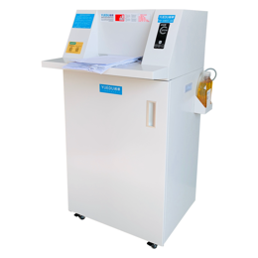 | 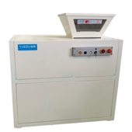
Features | 25-40 KG per hour | 40-60 KG per hour | Affordable  1-2 tons per day | High horsepower, double inlet | Auto-refueling, silent | Auto-refueling, double inlet | Sleek design,  day 2-4 tons
Sheets | 25 | 35 | 60-120 | 40-130 | 42-52 | 38-60 | 90-180
Entry width | 31CM | 31CM | 50CM | Funnel Entry 50*38CM | 33CM | 33.8CM | Funnel Entry 51*48CM
Typical users | Tesa SE  Innovia Security  RBIS | FAW Toyota  Volkswagen  Foxconn | SEW  FAW Toyota  SK Hynix | Avery  Merck  Ford Motor | Heidelberg  J&J  GSK | 3M Labels  Panasonic  Eli Lilly | Henkel  Donnelley  Roche
 | https://youtu.be/U9MJ1mHHmjU | https://youtu.be/5V-NGy5HUaM | https://youtu.be/YaDVwhNikdI | https://youtu.be/O-Vc5TL1fwQ | https://youtu.be/yrWEiYl2YOA | https://youtu.be/5V-NGy5HUaM | https://youtu.be/AQA-l6mYNu8

